Report on mini project

NAME : Merwin Pinto

ROLL NO: 1

SRN : 202100102

Problem statement:

Implement RIP protocol and FTP Related concepts in a Network

Project Description:

RIP Routing with Multiple Devices Connected to the Switch and further connected to a Router ,Connected to a Server. Where there is an FTP Server used in our Network.

Objective of project :

The main purpose of this project is to gain understanding of Concepts of RIP protocol , how it works and understanding FTP server and its implementation

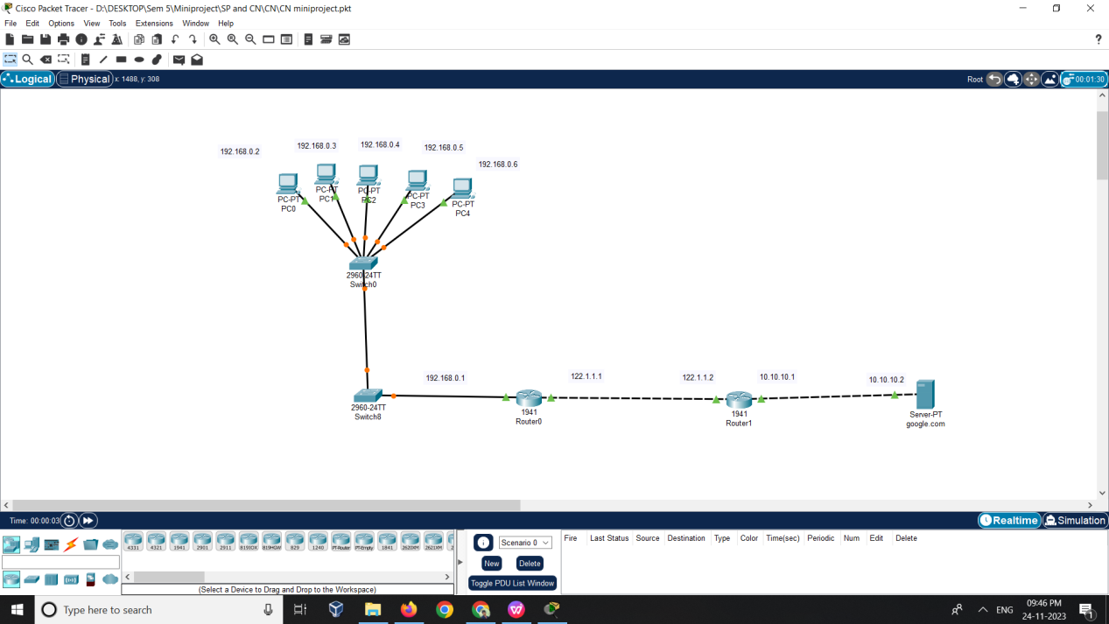

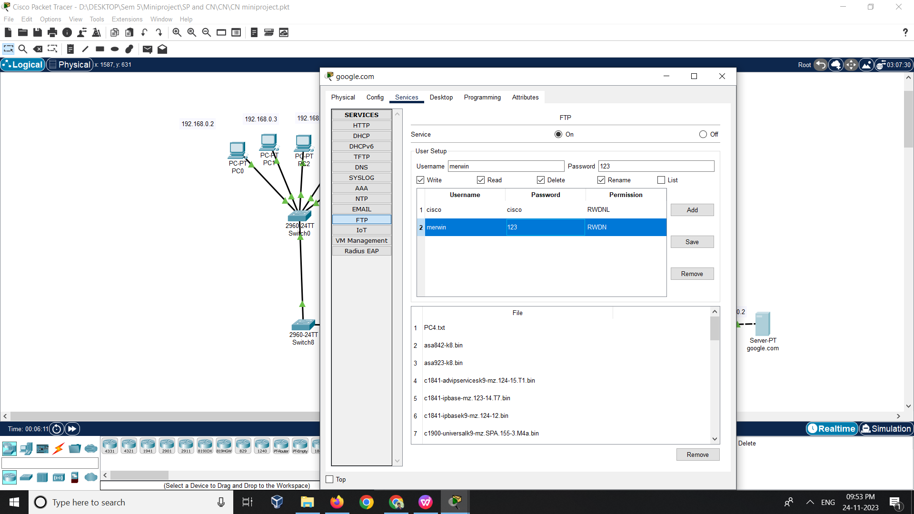

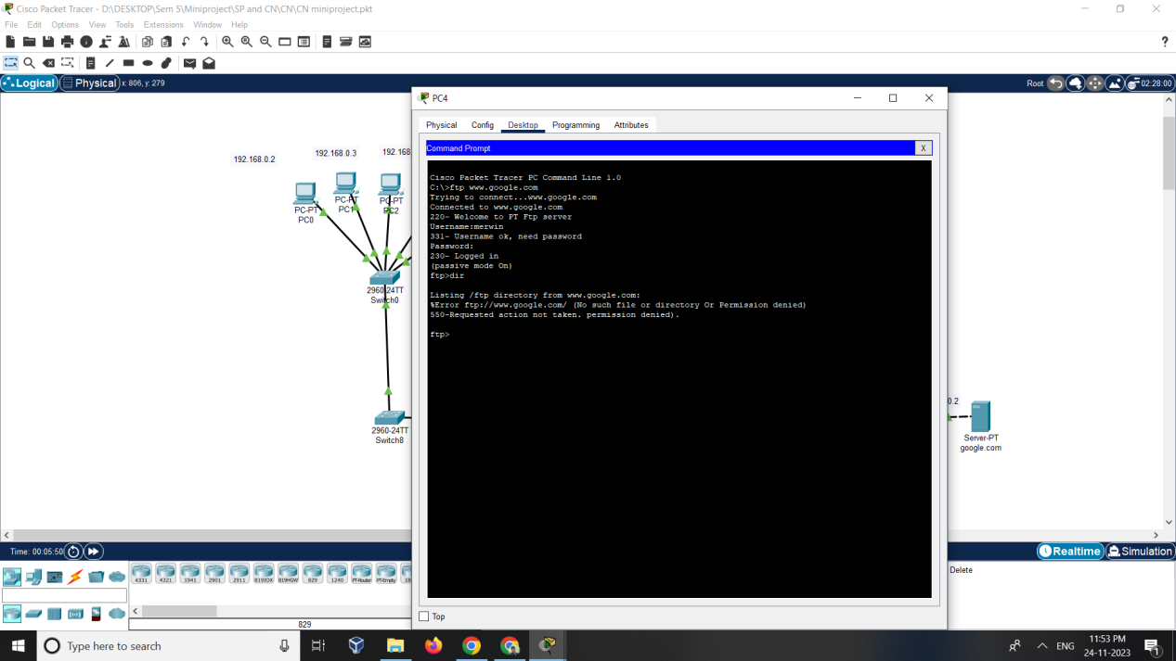

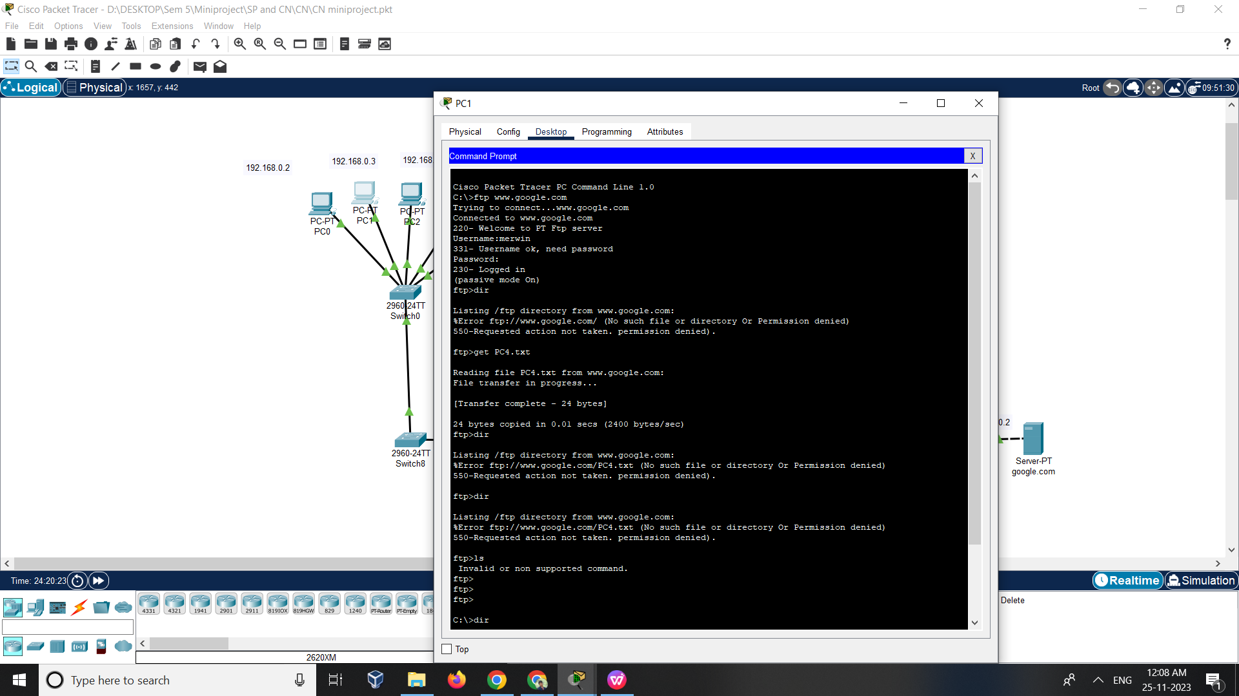

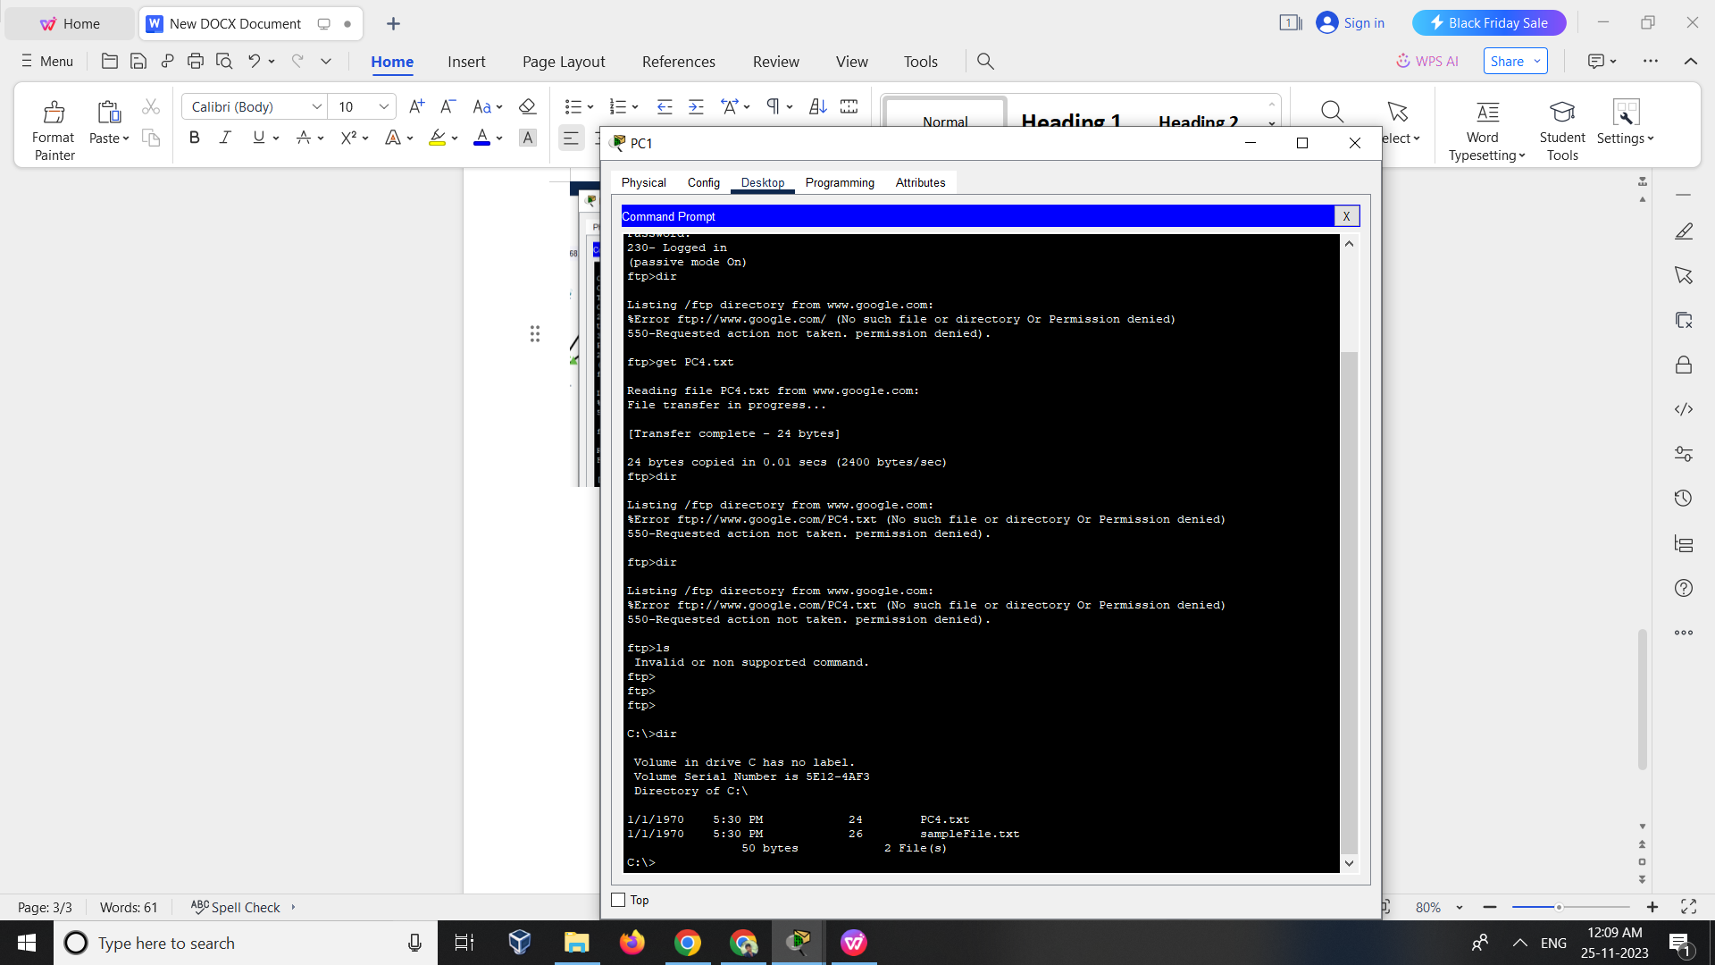

PART 3   
ANALYSIS AND OUTPUT PHASE

## Characteristics of FTP

1. FTP uses TCP as a transport layer protocol.
2. It is good for simple file transfers, such as during boot time.
3. Errors in the transmission (lost packets, checksum errors) must be handled by the TFTP server.
4. It uses only one connection through well-known port 69.
5. TFTP uses a simple lock-step protocol (each data packet needs to be acknowledged). Thus the throughput is limited.

## Advantages of FTP

* Speed is one of the advantages of FTP(File Transfer Protocol).
* File sharing also comes in the category of advantages of FTP in this between two machines files can be shared on the network.
* Efficiency is more in FTP.

## Disadvantages of FTP

* File size limit is the drawback of FTP only 2 GB size files can be transferred.
* Multiple receivers are not supported by the FTP.
* FTP does not encrypt the data this is one of the biggest drawbacks of FTP.
* FTP is unsecured we use login IDs and passwords making it secure but they can be attacked by hackers.

Main output would be that our Files were sent and received successfully !